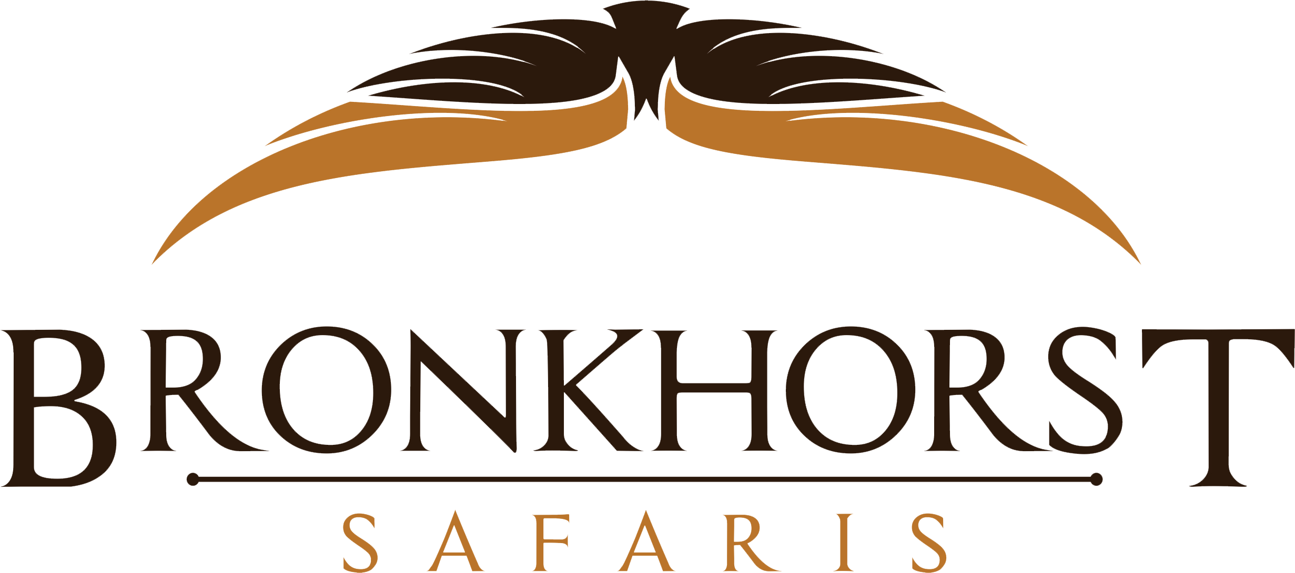

CLIENT INFORMATION SHEET

Dear Client,

In order to make your stay as enjoyable as possible and to cater for specific personal tastes, please complete this form and return soonest. Each hunter to complete his/her own form.

Full Name of Client: __________________________________________________
Birth date: _______________________Nationality: __________________________
Address: _____________________________________________________________
Email: _______________________________________________________________

Tel no: _________________________ Fax no: ______________________________
Passport number: __________________Exp. Date: ___________________________
Occupation: _____________________What size safari shirt do you wear? _________
Health Condition: ______________________________________________________
Do you have Medical Insurance? __________________________________________
Do you have Medevac Insurance? If yes, give full information? ________________ _____________________________________________________________________

Details of Observer/s:
Surname | Full Names | Age | Passport # | Expiry Date

Conditions we need to know of the observers traveling with you; ________________
_____________________________________________________________________

Flight details:
IT IS YOUR OWN RESPONSIBILITY TO CHECK VISA AND ENTRY REQUIREMENTS FOR THE COUNTRY YOU WILL BE VISITING OR IN TRANSIT OF.

Arriving date: __________Flight no: ________Time: _______From: __________
Departure date: _________Flight no: ________Time: _______To: ____________
First Day in Camp; ____________Last day in Camp; ________________________
Different details we need to know of regarding your observer’s flights if applicable;
Arriving date: __________Flight no: ________Time: _______From: __________
Departure date: _________Flight no: ________Time: _______To: ____________
First Day in Camp; ____________Last day in Camp; ________________________

Marketing Material
I also here-by agree and give permission to Phillip Bronkhorst and staff of Bronkhorst Safaris to use any photos and video material taken of me and my group during my intended safari to be used for the sole purpose of marketing for BRONKHORST SAFARIS
Yes _______________ No _______________

Rifle Information (NB: Persons must be 21 years or older to bring firearms into SA. Only 2 rifles of different calibre and 1 shotgun allowed per hunter (NO semi or automatics!)
Documents to bring along | Tick Box | Special Notes
Proof of Ownership of Rifle (US 4457)
PBS Safari Invitation Form
Firearm Import Export Form (SAP 520)
Copy of Passport
Copy of Flight Ticket

Make Calibre Serial # Rounds max 100
- _______________ __________ _______________ _________________
- _______________ __________ _______________ _________________
- _______________ __________ _______________ _________________

Please state if you have hunted in any African country and name the species taken:
__________________________________________________________________________________________________________________________________________
_____________________________________________________________________
_____________________________________________________________________
Please state if there are any other requirements that need to be considered on the hunt:
__________________________________________________________________________________________________________________________________________
_____________________________________________________________________

Food and Drink Requirements

We will try out outmost best to provide you with your favorite drink if available in the destination of your safari. Certain drinks are not available.

BEVERAGES | YES | NO | FOOD | YES | NO
Coke/Soda |  |  | Beef
Diet drinks |  |  | Lamb
Fruit Juices |  |  | Pork
Fresh Juices |  |  | Chicken
Beer/Malt |  |  | Venison
White wine |  |  | Salads
Red wine |  |  | Vegetables
Dry/off dry wine |  |  | Potatoes
Semi sweet wine |  |  | Fish
Sparkling wine |  |  | Fruits
Scotch whisky |  |  | Caffeine free Drinks
Bourbon |  |  | Coffee
Gin |  |  | Tea
Vodka |  |  | Breakfast
Rum |  |  | Brunch
Other |  |  | Lunch

Any food and drink requirements we need to know of: _____________________________________________________________________
_____________________________________________________________________
_____________________________________________________________________

SPECIE ALLOCATION FORM
TROPHIES | SPECIAL NOTE | YES | LP | MPB | G | NW | FS | EC
AFRICAN WILD CAT | Hunting Permit |  | X | X |  |  | X
BABOON | Hunting Permit |  | X
BONTEBOK | CITES Permit |  |  |  |  | X | X
BLESBUCK COMMON |  |  | X | X | X | X | X | X
BLESBUCK COPPER |  |  |  |  |  | X | X
BLESBUCK WHITE |  |  | X |  |  |  | X
BLESBUCK YELLOW |  |  |  |  |  | X | X
BUFFALO BULL |  |  | X | X |  | X | X
BUFFALO COW |  |  | X
BUSHBUCK LIMPOPO |  |  | X
BUSHBUCK EAST CAPE |  |  |  |  |  |  |  | X
BUSHPIG |  |  | X | X |  |  |  | X
CARACAL | Hunting Permit |  | X |  |  |  | X | X
COMMON REEDBUCK | TOPS Permit |  | X | X |  |  | X
CIVET CAT | Hunting Permit |  | X
CROCODILE | Hunting Permit |  | X | X |  | X
DUIKER BLUE | TOPS Permit |  |  |  |  |  |  | X
DUIKER RED
DUIKER COMMON |  |  | X | X | X | X | X | X
ELAND CAPE |  |  | X | X |  | X | X
ELAND LIVINGSTON |  |  | X
ELEPHANT | CITES Permit |  | X | X
FALLOW DEER |  |  |  | X |  |  | X
GEMSBUCK |  |  | X | X | X | X | X | X
GEMSBUCK GOLDEN |  |  | X |  |  | X | X
GENET CAT | Hunting Permit |  | X | X |  |  | X | X
GIRAFFE |  |  | X | X
HIPPOPOTAMUS | CITES Permit |  | X | X
HONEY BADGER | Hunting Permit |  | X | X
HYENA SPOTTED | CITES Permit |  | X | X
HYENA BROWN (Non-USA) | Hunting Permit |  | X
GRYSBUCK SHARPES | Hunting Permit |  | X
GRYSBUCK EAST CAPE |  |  |  |  |  |  |  | X
IMPALA BLACK |  |  | X |  |  | X | X | X
IMPALA COMMON |  |  | X | X | X | X | X | X
IMPALA SADDLEBACK |  |  | X |  |  |  | X
IMPALA WHITE FLANKED |  |  | X |  |  |  | X
JACKAL |  |  | X | X | X | X | X | X
KUDU SOUTHERN GREATER |  |  | X | X |  | X | X
KUDU EASTERN CAPE |  |  |  |  |  |  |  | X
KLIPSPRINGER |  |  | X |  |  |  |  | X
LION | Hunting Permit |  |  |  |  | X
LIONESS |  |  |  |  |  | X
LEOPARD | CITES Permit |  | X
MOUNTAIN REEDBUCK |  |  | X | X | X |  | X | X
NYALA |  |  | X | X |  |  | X | X
ORIBI | Hunting Permit |  |  | X |  |  |  | X
OSTRICH |  |  | X | X | X | X | X | X
PORCUPINE | Hunting Permit |  | X | X | X | X | X | X
RED HARTEBEEST (CAPE) |  |  | X | X | X | X | X | X
RED LECHWE (COMMON) |  |  |  | X |  | X | X | X
RHINO WHITE | Hunting Permit |  | X |  |  | X | X
RHINO WHITE VITA DART |  |  |  |  |  |  |  | X
ROAN ANTELOPE | Hunting Permit |  | X |  |  | X | X
TROPHIES | SPECIAL NOTE | YES | LP | MPB | G | NW | FS | EC
SABLE ANTELOPE |  |  | X | X | X | X | X | X
SERVAL CAT | Hunting Permit |  |  | X
SPRINGBUCK BLACK |  |  | X |  |  | X | X | X
SPRINGBUCK COMMON |  |  | X | X | X | X | X | X
SPRINGBUCK COPPER |  |  | X |  |  | X | X | X
SPRINGBUCK KALAHARI |  |  |  |  |  | X | X
SPRINGBUCK WHITE |  |  | X |  | X | X | X | X
STEENBUCK |  |  | X | X | X | X | X | X
SUNI | CITES Permit
TSESSEBE |  |  | X | X |  |  | X
VERVET MONKEY | Hunting Permit |  | X
VAAL RHEBUCK | Hunting Permit |  |  | X |  |  | X | X
WARTHOG |  |  | X | X
WATERBUCK |  |  | X | X | X | X | X | X
WILDEBEEST BLACK | Hunting Permit |  | X | X | X | X | X | X
WILDEBEEST BLUE |  |  | X | X | X | X | X | X
WILDEBEEST GOLDEN |  |  | X |  |  | X | X
WILDEBEEST KINGS |  |  | X |  |  |  | X
ZEBRA BURCHELLS |  |  | X | X | X | X | X | X
ZEBRA HARTMANS | CITES Permit |  |  |  |  |  | X
GAME BIRDS | Hunting Permit |  | X | X | X | X | X | X

